**Math I - UNIT 2 Part 3 Homework: Due Monday, Dec. 7**

**1-: Write an equation in slope-intercept form**

|  |  |
| --- | --- |
| ***x*** | ***y*** |
| -4 | 1 |
| -1 | -2 |
| 1 | -4 |

**1.** (-1, 2) (3, 4) **2. 3.**  (0, 5) (3, 5)

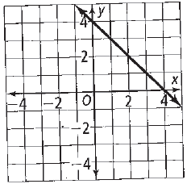**4.**

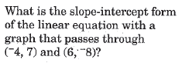 **5.**

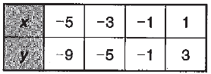

**6.** *m* = 2 and (-1, 5) **7.**

**Graph 8 – 10**

**8.** *y* = 3*x* – 3 **9.** *x* + 3*y* = 9 **10**. 4*x*– 2*y* + 7 = 3*x* + 5

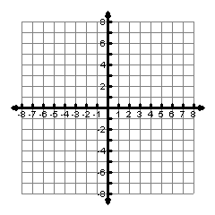

**For numbers 11 – 15: If *f*(*x*) = 2*x* + 1 and *g*(*x*) = 2*x*² - 5*x*, find each value**

**11.** *f*(-4) **12.** *g*(2) **13.** *f*(3) **14.** *f*(5) **15.** *g*(3)

**16.** Which of the following is an equation of a line that is

parallel to the line *l* in the graph?

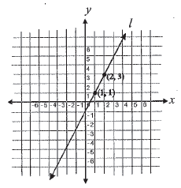

1. *x* – 2*y* = -4
2. *x* – 2*y* = 4
3. 2*x* + *y* = 4
4. 2*x* – *y* = 4

**17.** Write an equation to a line that is perpendicular to line AD

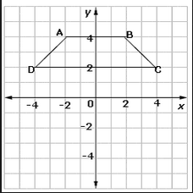

**18**. Write an equation of the line with a y-intercept of -2 and parallel to the line *y* = – 5.

**19.** Write an equation of the line with a y-intercept of 7 and perpendicular to the line 4*x* – 6*y* = 12.